# Worldbuilding

* Location:  
    
  a frozen planet that might have life beneath its icy surface – water combines with possible geothermal fissures to support life.  
    
  The planet has been knocked off its previous orbit whch was in the goldilocks zone – similar distance from sun to our Earth – further away, which caused it to cool down so much. It used to be about 90% covered by water, which now all turned into thick ice – multiple meters deep.  
    
  The sky on this planet is a deeper purple – caused by a thinner atmosphere.   
    
  the atmosphere has a lot of Neon in it, which causes Auroras – a pretty frequent phenomenon on this planet – to be orange and red.
* Name of world:

105KR by the official numbering system, but often nicknamed Krios by its dwellers.

* Physical Law / Natural Phenomena:  
    
  low gravity, similar to that of the moon. Common ice storms which are moreso caused by blowing wind rather than acctual weather. Beneath the surface, common eruptions of underwater volcanoes and tremors – these have a subtle effect on the surface, as it is muted by the water
* Climate & Biodiversity: Identify the world’s climate and describe types of Flora & Fauna that can be found there.  
    
  the Climate is cold, with weaker sunlight on the surface. Only frozen trees with deep roots that reach the water through the frozen ground and ice. These are the only surface surviving species. Frozen fossils of animals and even plants can be found.   
    
  beneath the surface, however, is a whole underwater ecosystem. Nurtured not by photosynthesis, but by the geothermal energy. Species tend to be small, up to 2 meters. It seems, however, that one species of squid might be sentient, with its own society and usage of tools. (similar to our real world squids, but more civilization-based)
* Race (s) and population.  
    
  a tardigrade species has arrived on Krios to colonize it. They have a successfull colony that can sustain itself, which merely relies on their food source – moss, black blind worms, cultivated in a greenhouse together with mirobes and bacteria to ensure a stable ecosystem.

the Tardigrades are quite small – about 10 cm. They are very sturdy, and can withstand harsh environments with a simple suit, that keeps them moist. They have the impressive ability to dry up, which makes them hibernate, in a way. They can then be revived by water.  
   
 They are also very crafty. Their small size and low standards for living allows them to make things on the fly – makeshift machines and vehicles are not unusual.  
  
 Language:  
 There isn’t that much emphasis on death for the Tardigrades, as they can survive pretty much anywhere. The closest word they have for death is “Lost”, as that’s the only way someone could disappear forever – dried up in the middle of space with no one to rescue them.

* Culture & Law/ Rules.  
    
  Related to their perceived immortality – for one, the value of a life is shifted. Loads of Tardigrades are intentionally dried up to conserve resources in times of need.   
    
  many spaceships have their members ranked in order of “self-sustainability” - This dictates the order of people to be revitalized in the ship to serve as a permanent crew. The first on this list is the tardigrade that knows the most about the ship and could handle as many problems on their own as possible. They are dubbed the “ever-awake”, as they are always keeping watch on the ship full of slumbering comrades. They aren’t usually the one in command, as communications and diplomacy aren’t as time-sensitive as a faulty engine that’s about to blow up.   
    
  their culture is focused towards the collective rather than the individual – similar to japanese culture in that front.   
    
  They worship trees specifically, as they are symbolize their goal of reaching to the skies, while living up to hundreds of years. Ancients groves are holy places, and deforestation is only done on younger trees, and only if necessary.  
    
  Rites of the lost – it's customary to send out a “final searching vessel” to find the lost. On their home planet – a balloon, or a lantern with their names and keepsakes. In space colonies, some may send a satellite/similar device in their honour, even though it may serve a different, utilitarian purpose as well.   
    
  If a tardigrade dies by some external means – by a predator, for example – the custom is to bury them underneath a tree if possible.
* Technology  
    
  Alternative to cryo-chambers: dry up chambers, which can then be activated manually or on a timer – painlessly dries up the tardigrade for a period of time to hibernate them, then waters them again.   
    
  space suits – not completely enclosed like ours, in fact, the head is out in the open. They wear headgear based on their rank – not exactly protective.

On this specific planet - a makeshift submarine made from metals found on 105KR. Its purpose is to allow for better vision in the watery depths, as well as seem bigger to predators.

* History.  
    
  The tardigrades have long been colonizing all sorts of planets. With their constitution, they’re able to survive almost any climate. Dry up chambers have allowed for long journeys across the cosmos. Time has never been an issue for them, some vessels have travelled for decades with a dried up crew.   
  Their home planet isn’t doing well, however. The tardigrades, being quite small, have sucessfully eradicated their natural predators. This has damaged the ecosystem, meaning that most of their home planet’s resources are spent on preserving whatever species they can, as well as trying to prevent the ecosystem from collapsing.

([Halicephalobus mephisto - Wikipedia](https://en.wikipedia.org/wiki/Halicephalobus_mephisto)

[These 17 Icy Worlds Could Have Warm Oceans Full of Alien Life (inverse.com)](https://www.inverse.com/science/exoplanet-ice-oceans-support-life)

[SKY & PLANT COLOR ft. Worldbuilding Notes (youtube.com)](https://www.youtube.com/watch?v=L9MNC45Jr6Q)

[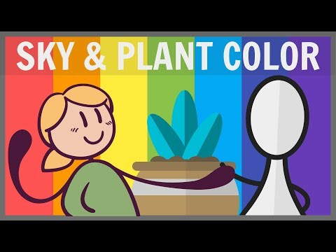](https://www.youtube.com/watch?v=L9MNC45Jr6Q)

# Concepts and models:

Moodboards for the race and planet:

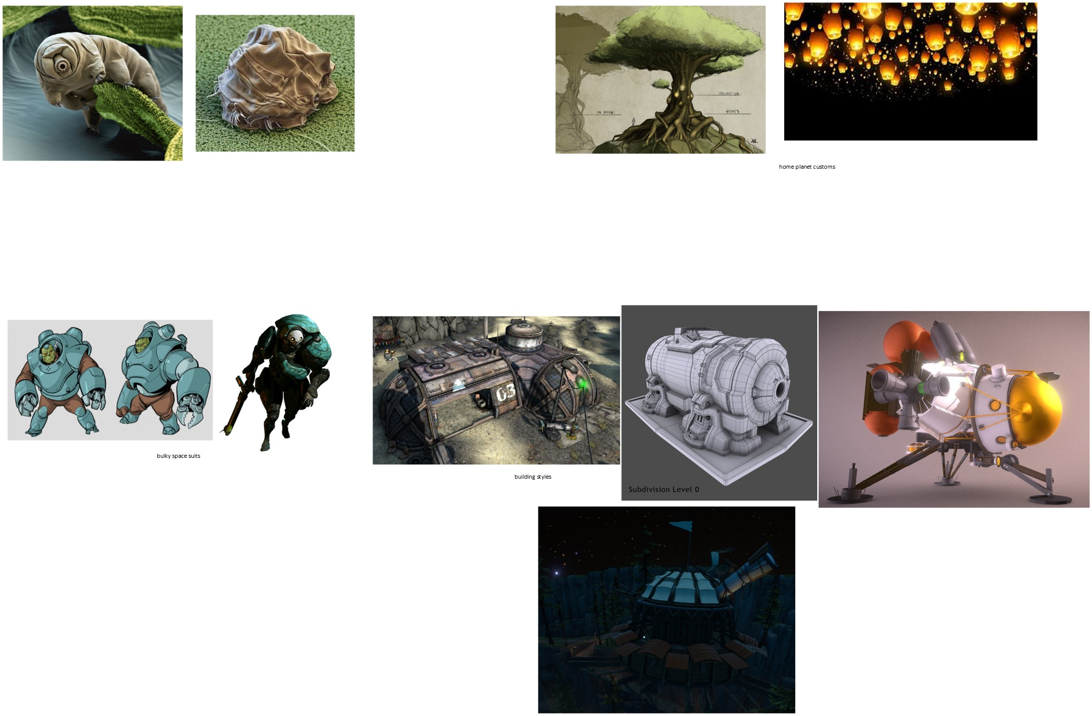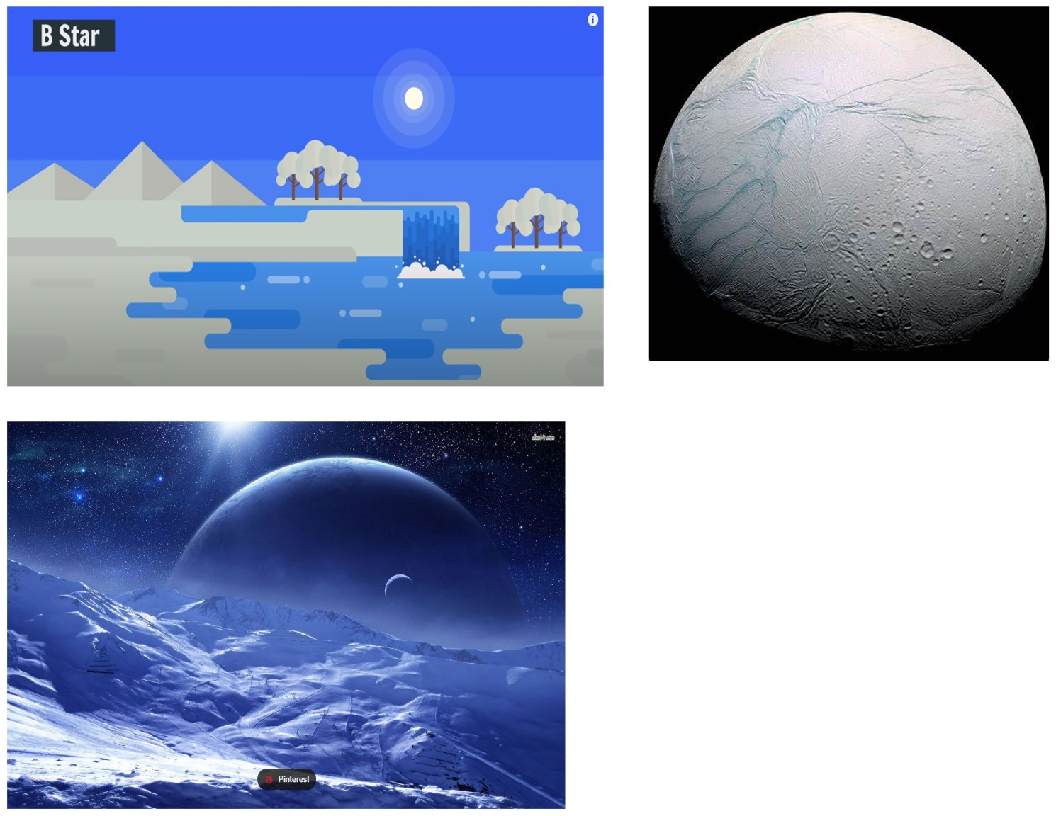

The general overworld landscape is depicted in this concept art:

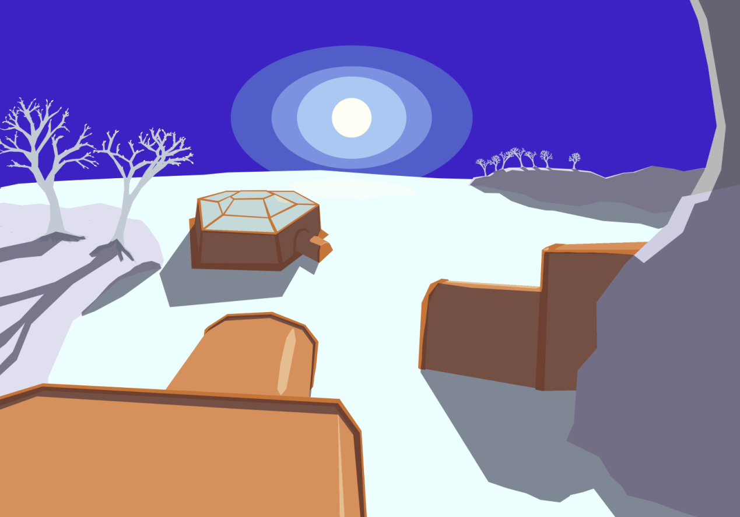

Underwater concept art (beneath a huge layer of ice)

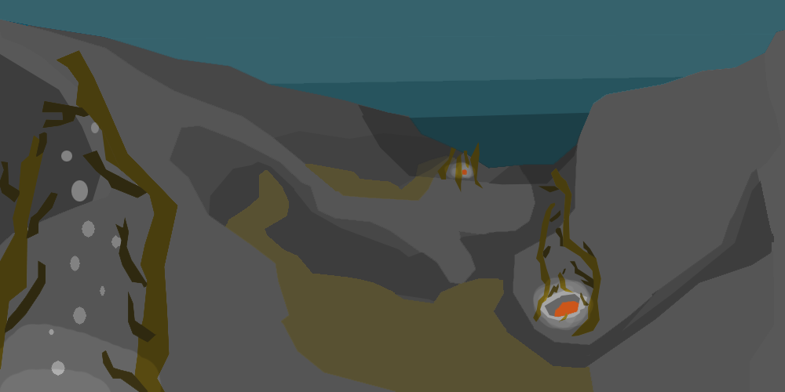

3D models: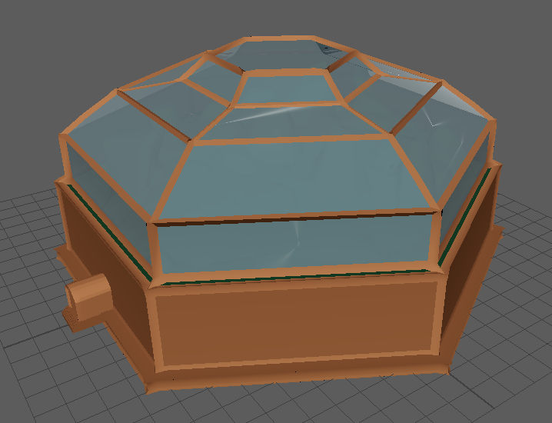

Big metal structure that serves as a greenhouse and a source of food for the colony. The design in igloo-like – precious warmth stays up where the plants are. the glass is almost like a one-way mirror, to not let sunshine out.

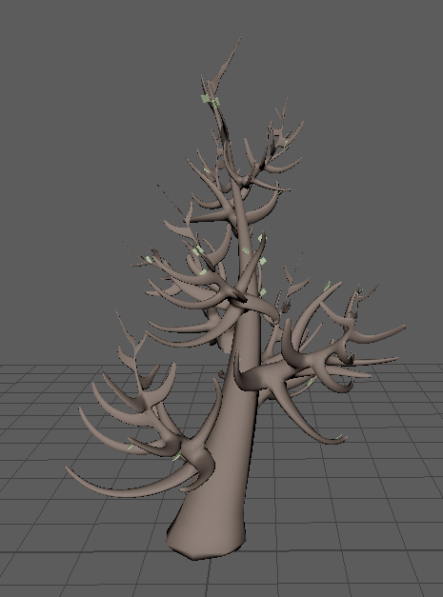

Desaturated trees on the surface, they still have a few leaves, proving that they manage to live in these harsh frozen conditions.

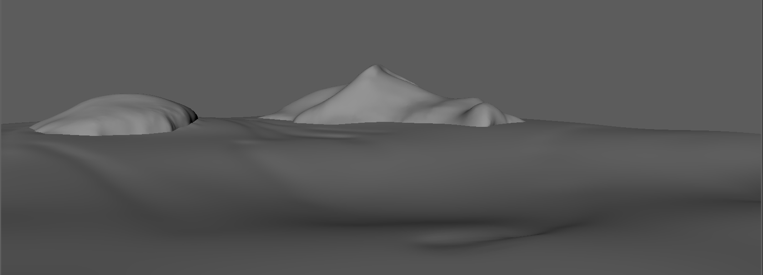Bland surface, covered by ice and snow. Few peaks of previous islands still poke out of the ice.

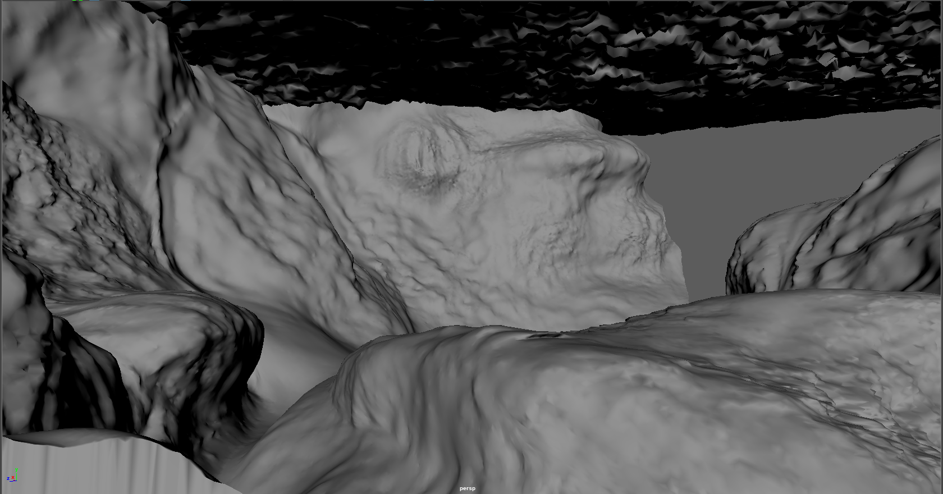

But right underneath, the varied underwater landscape is filled with kelp living off of geothermal energy, and many other organisms. A full ecosystem encased in an icy shell.

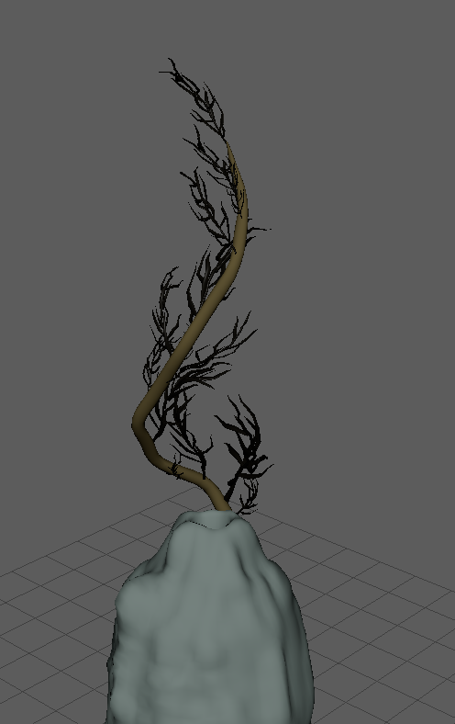

The said kelp has evolved strong enough trunks to stay atop the geothermal vent, they grow in groups or alone, gathered around these sources of heat. Their black fronds flail in the hot current, absorbing energy.

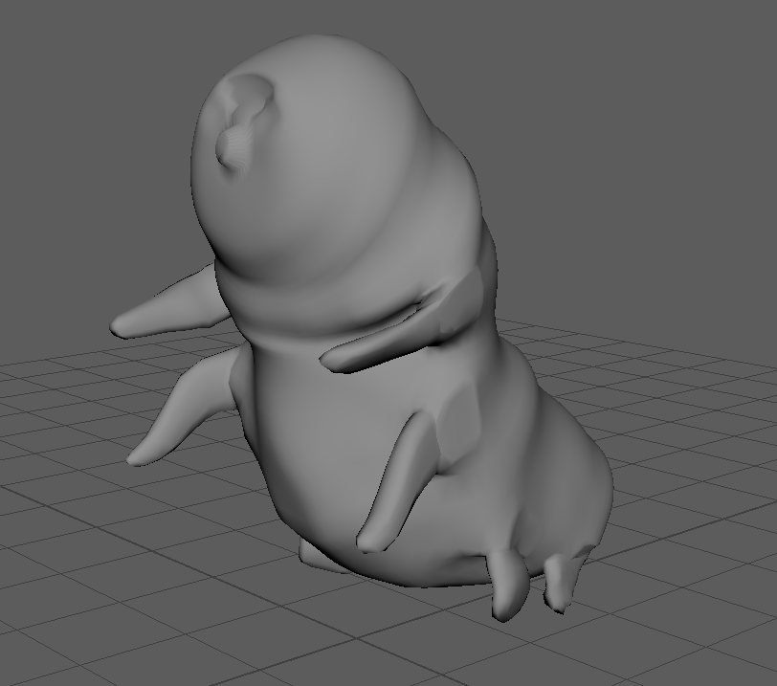The incoming tardigrade species that came to colonize the planet has evolved to walk on 4 of their 8 lags, with their front 4 being longer than usual to make building and crafting easier.